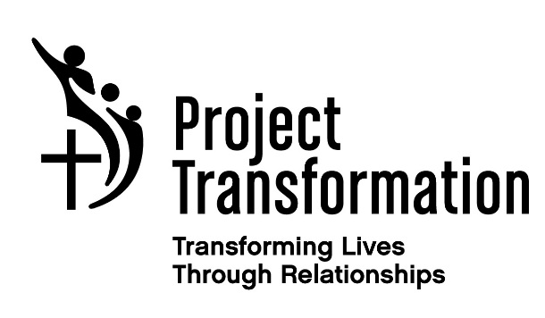

Partner Church Letter of Commitment
Please check which program with which you will partner:
Dallas Sites: ___ Denison Site: ___
We, the congregation of ____________________________________agree to partner with Project Transformation in Summer 2017. By this commitment we are willing to provide the following (Please initial):
_____Provide or adopt a highly capable, motivated college student(s) to participate in Project Transformation as a summer intern.
____Contribute $1,500 to cover a portion of the intern's living stipend.
____Provide 2 dinners during the summer for the 100 interns in the Dallas program or 10 interns in the Sherman/Denison program. This will be an opportunity to eat with the interns and learn about their experiences with the children at the different sites. You will also be lending emotional support and encouragement to the interns.
_____Assist with the Summer Reading Program, by providing 10-15 volunteers to read one-on-one with the children for one to two weeks (Mon-Thurs) of the Summer Program.
_____Donate program supplies, books, and snacks for two weeks. A list of program needs is available on our wish list.
We also agree to:
_____Attend Dallas Area Partner Church Meeting on ___________ at 7:00 PM. Location TBA.
_____Attend Sherman/Denison Partner Church Meeting on ____________ at 7:00 PM. Location TBA.
_____Submit Partner Church financial commitment May 15, 2017 if possible. Early sign ups for reading and dinner volunteers will begin on March 5, 2017 for those churches whose financial commitment has already been received.
Each partner church will have a contact person. This is someone who will commit to being a liaison between Project Transformation and the church. It is important for this person to attend the partner church meeting to get important information for the summer program and network with other partner churches. They will also commit to coordinate the above components.

Church:
Mailing Address:
City, State, Zip:
Contact’s Name:
Contact’s Role in the Church:
Contact’s Phone Number:
Contact’s Email:
Contact’s Mailing address (if not the church):
Thank you for supporting Project Transformation! We are grateful for your partnership in ministry as we engage young adults in leadership and ministry, support underserved children and families, and connect churches to communities in need.
_________________________________________________________
Contact’s Signature
___________________________________________________________
Pastor’s Name (Please print)
___________________________________________________________
Pastor's Signature

Please mail or fax this form to:
Lynne Rhodes
Project Transformation North Texas
4024 Caruth Blvd.
Dallas, TX 75225
214-946-3600
214-946-3651 (fax)

Thank you!

