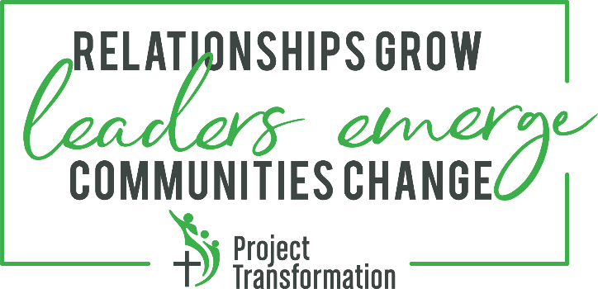
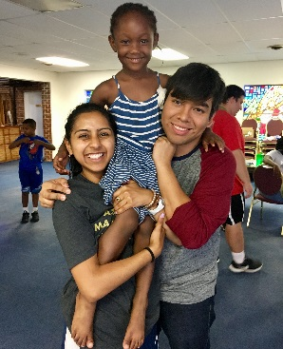

Provisional New Chapter Application
Thank you for your interest in starting a new chapter of Project Transformation! Launching a new Project Transformation program is an exciting and challenging endeavor. Project Transformation’s national organization is committed to expanding this ministry in a sustainable way to fulfill our mission of transforming communities by engaging children, college-age young adults, and churches in purposeful relationships. At Project Transformation, we envision a world that is rooted in love, pursues the equity of all people, and amplifies God’s call on every life. Grounded in our core values, it is our intention to develop a network of Project Transformation chapters throughout the country by partnering with local churches and communities, and a number of other ministry partners.

Applying to Become a Project Transformation Chapter
In order to be approved as a Full Status Chapter of Project Transformation, Core Leadership Teams must first apply for provisional recognition. This is achieved by meeting the provisional recognition requirements outlined in the Guideposts for New Chapter Development and submitting this Provisional New Chapter Application to PT National for review and approval. PT National recommends that provisional chapter applications be submitted approximately 21-24 months in advance of a proposed summer program start date. Approved provisional chapters of Project Transformation will enter into an affiliation agreement with Project Transformation National and will be granted permission to participate in network-wide training and retreats, form a board of directors, and seek independent 501(c)3 nonprofit status under the name “Project Transformation”.

Applications will be reviewed by the Project Transformation National Board of Directors within two months of receipt. Completed applications should be sent by email to:

Eric Lindh
Project Transformation National
lindh@projecttransformation.org

CONTACT INFORMATION:

Primary Contact Name:

Primary Contact Email:

Primary Contact Phone:

Address:

City, ST, Zip:

United Methodist Conference and/or other regional denominational affiliations:

CORE LEADERSHIP TEAM INFORMATION:

List the Core Leadership Team Members and Affiliations
Core Leadership Teams should consist of approximately 6-10 people and include representatives from the communities in which the new chapter plans to establish the program, United Methodist and/or other denominational leaders, Project Transformation alumni, individuals with access to financial resources and/or an ability to raise start-up capital for PT, and other church, community, and business leaders who are committed to launching Project Transformation:

Lead Champion:

Core Leadership Team members who have participated in initial training sessions provided by PT National:

DEMONSTRATED INTEREST AND ALIGNMENT WITH MISSION AND VALUES
Why are you interested in starting Project Transformation in your region and when do you plan on beginning the first summer program?

LOCAL CHURCH/COMMUNITY CULTURE

Project Transformation’s unique model of ministry requires a high degree of collaboration between churches, United Methodist and/or other denominational institutions, and other community partners. What evidence exists in your area that demonstrates a collaborative spirit and/or willingness to leverage the connectional nature of the church and other creative partnerships to allow the Project Transformation model to thrive?

FINANCIAL SUPPORT

Launching a new Chapter of Project Transformation requires a significant initial financial investment as well as ongoing fundraising effort. A minimum of $100,000 (roughly 50% of the first year’s operations) must be secured or committed prior to approval as a provisional new Chapter. List the funding secured/committed to date and each revenue source (church, foundation, individuals, corporations, etc.)

An additional $100,000 should be secured/committed prior to approval of full Chapter status or hiring any full-time staff. What are your plans for securing this additional funding?

ORGANIZATIONAL STRUCTURE

Project Transformation National recommends that approved provisional chapters apply to become independent 501(c)3 nonprofit organizations. Are you prepared to seek 501(c)3 status?

Proposed new Chapter Name (e.g. Project Transformation North Georgia, Project Transformation Oklahoma, etc.):

PARTNER CHURCH/ORGANIZATIONAL SUPPORT

At Project Transformation, we believe in the power of the church’s connectional nature. We believe the local church is an essential partner in community transformation. A critical component of Project Transformation’s success is harnessing widespread support from partnering churches and other local organizations to provide funding, volunteers, meals, and other in-kind resources. It is recommended that new chapters secure commitments from at least eight partner churches or other partner organizations per each host church prior to approval as a full status Chapter. List all churches and other entities that have been asked or you plan to ask for support.

HOST CHURCHES
List at least two to three churches that have been identified as potential host churches for Project Transformation’s summer program? For each host church, explain why you believe it might be a good fit as a host church for Project Transformation.

COMMUNITY LIVING
Project Transformation’s young adult interns are required to live in community during the summer. Housing is often secured through a partnership with a local college or university. Describe the community housing arrangements that you anticipate exploring. If possible, include the name of the institution, type of housing arrangement (Greek housing, dorms, apartments, etc.), expected cost, availability of community space for dinner, meetings, or worship, and bed capacity.

STAFF LEADERSHIP
It is recommended that at least two, full-time staff lead the program who bring Project Transformation leadership experience and local community connections. List any potential staff who have been identified or expressed interest. Please include a description of their qualifications, including past experience with Project Transformation, leadership experience, and knowledge of and relationships with the local community.

MINISTRY EXPLORATION / VOCATION DISCERNMENT
A key component of the summer internship for young adults is exploring a variety of vocations in ministry and service. This primarily occurs through “Friday Experiences.” Each Friday morning, interns meet with various church and nonprofit ministry leaders in the area to explore different vocational opportunities in ministry and service. These Friday Experiences help expose young adults to various forms of ministry through tours, interactive experiences, and discussions and expand their understanding of what it looks like to be in ministry. Please include a list of at least six potential Friday Experience options you expect to incorporate into the interns’ summer experience (Ex: churches, institutions, nonprofit ministries, seminaries, etc.)

PROGRAM PARTNERSHIPS
Project Transformation’s program model has specific components that are supported through a variety of local partnerships. Please answer the following questions addressing your plans to secure these partnerships:
a. The summer reading program is a unique feature of Project Transformation, as it relies on 10-15 volunteers each day per site for eight weeks to read one-on-one with the children. Describe your plans for recruiting reading volunteers for the summer program.
b. Children participating in Project Transformation are provided with healthy meals every day for lunch. List any potential partnerships that could provide these meals (e.g. local food banks, state feeding program, etc.).
c. The summer reading program, as well as other enrichment activities such as young artists, recreation, and Bible lessons require donated children’s books and curriculum supplies. Describe your plans for securing these donations.
d. Interns share a communal meal Sunday-Thursday evenings with church volunteer groups for the entire summer. Describe your plans to recruit church groups and other partners to provide these meals.

PROGRAM BUDGET
Attach a projected budget for the first full year of operations (include income sources and expenses).

