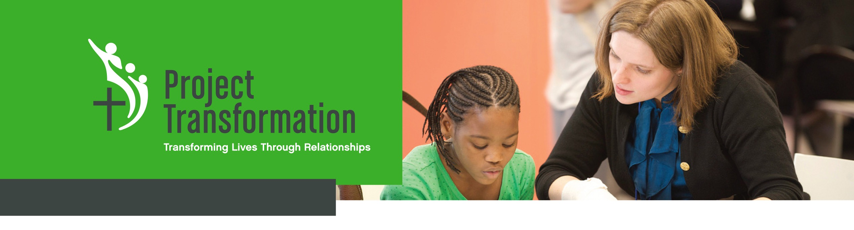
New Chapter Application
Thank you for your interest in starting a new chapter of Project Transformation! Launching a new Project Transformation program is an exciting and challenging endeavor. We are very interested in expanding this ministry in a sustainable way to reach our mission of engaging young adults in purposeful leadership and ministry, supporting underserved children and families, and connecting churches to communities in need.

Our vision is for Project Transformation to be a respected national model through which leaders emerge, communities change, and lives transform. It is our intention to develop a network of Project Transformation chapters throughout the country by partnering with local churches, ministry partners and conferences of the United Methodist Church. Each chapter will enter into a Chapter Affiliation and Trademark Agreement with Project Transformation National and will share the same mission statement and core program components, but will have independent legal status, staff, and board leadership along with support, oversight, and assistance of a national staff and Board of Directors.

Each potential Project Transformation chapter is required to complete the following Chapter Application. In addition, all applicants must form a Core Leadership Team or steering committee, which should include a combination of conference staff, clergy, lay leaders, and business and community leaders. One person must be designated as the primary contact and ‘Lead Champion.’ Project Transformation is committed to providing the highest quality programs to our young adults and the children they serve; therefore, this application addresses key factors that will ensure the success of each new chapter and that you have met all requirements. We recommend that applications are submitted at least 15 months prior to target launch date. Applications will be reviewed by the Project Transformation National Board of Directors within two months of receipt. Each leadership team that is interested in forming a new chapter is required to complete an application and mail or email to:

Eric Lindh
Project Transformation National
4024 Caruth Blvd
Dallas, TX 75225
lindh@projecttransformation.org
CONTACT INFORMATION:

United Methodist Conference:

Address:

City, ST, Zip:

Conference website:

Conference Phone:

Conference Fax:

Primary Contact Name:

Primary Contact Email:

Primary Contact Phone:

Core Leadership Team Members and Affiliations:

Why are you interested in starting Project Transformation in your conference?

CHURCH/CONFERENCE CULTURE

Project Transformation’s unique model of ministry requires a high degree of collaboration between churches, the conference, United Methodist institutions, and other community partners. What evidence exists in your area that demonstrates a collaborative spirit and/or willingness to leverage the connectional nature of the United Methodist Church and other creative partnerships to allow the Project Transformation model to thrive?

ORGANIZATIONAL STRUCTURE

Every Project Transformation chapter must be organized as its own nonprofit entity or as a program under the umbrella and fiscal sponsorship of the annual conference or other existing 501(c)(3) organization. Describe how the new chapter will be organized initially? In the long-term? Why do you believe this is the best way to be structured? Where will the administrative office be housed?

PARTNER CHURCH SUPPORT

A critical feature of Project Transformation is widespread support from United Methodist churches in the conference. It is recommended that at least ten partner churches have committed support prior to applying. Please list all churches and other entities asked to support the launch of Project Transformation with financial, volunteer and in-kind support. (Include each church’s response to date and dollar amount committed)

SITE CHURCHES
List the site churches that have been identified to host Project Transformation’s summer program for underserved children? For each site church, answer the following:

a. What does the church hope to accomplish through a partnership with Project Transformation?
b. What are the demographics and needs of the community surrounding the church?

c. What percentage of students from the nearest elementary school qualify for free or reduced priced meals?
d. Does the church have a long-range plan for how the church and neighborhood could benefit from hosting Project Transformation? How does the congregation anticipate engaging with the families that participate in the program? In what ways does the church anticipate supporting this ministry? (For example, volunteering to read with children, having lunch with the children and interns, providing a host to greet reading volunteers from other churches, collecting program supplies, etc.)

e. Describe the site church facilities (Does it have adequate space for classrooms, recreation, library, and kitchen?) Is there someone at the church who would be responsible for maintenance and upkeep of the facility? For liability reasons, it is necessary to have a pastor, staff member or authorized church member at the church while children and interns are present. List the name and contact information for this person.
f. In what ways will the conference work strategically with the site church to utilize Project Transformation’s partnership to bring about revitalization in the church and community?

COMMUNITY LIVING
Project Transformation’s young adult interns are required to live in community living during the summer. Housing is usually secured through a partnership with a local college or university. Describe the community housing arrangements that you have secured or you expect to secure. Include the name of the institution, type of housing (fraternity house, dorms, apartments, etc.), cost, availability of community dining space, and bed capacity. If housing is not yet secured, provide the status to date.

STAFF LEADERSHIP
It is highly recommended that at least two, paid staff members lead the program with at least one having first-hand Project Transformation experience. List any potential staff who have been identified or hired. Please include a description of their qualifications and past experience with Project Transformation.

INTERN RECRUITMENT
The success of Project Transformation is highly dependent on the quality of interns that are recruited to serve. Each chapter is responsible for recruiting high-caliber, college-age young adults to serve as summer interns with Project Transformation. List your recruiting strategies, progress to date, and all individuals who will be responsible for recruiting interns.

FINANCIAL SUPPORT

Launching Project Transformation requires a significant initial financial investment as well as ongoing fundraising effort. List all revenue sources (individuals, foundations, churches, etc.) and amount of financial support secured, committed or pending. What person(s) are primarily responsible for raising funds? What are your plans for securing funding after the first year?

PROGRAM BUDGET
Attach a detailed, projected budget including income sources and expenses.

PROGRAM PARTNERSHIPS
Project Transformation’s program model has specific components that must be included in all new chapters. Please answer the following questions addressing key program components:
a. The summer reading program is a unique feature of Project Transformation, as it relies on 10-15 volunteers each day per site for eight weeks to read one-on-one with the children. Describe your plans for recruiting reading volunteers for the summer program.
b. Children participating in Project Transformation are provided with healthy meals every day for lunch. Describe your progress towards securing a partnership with the local food bank or state feeding program.
c. Arts enrichment, recreation, Bible lessons, afternoon enrichment and the reading program require the donation of curriculum supplies and children’s books. Describe your plans for securing these donations.
d. Interns share a communal meal Sunday-Thursday evenings with church volunteer groups for the entire summer. Describe your plans to recruit church groups to provide these meals.

If you plan to begin Project Transformation in partnership with or as a program of an existing organization, please attach the organization’s operating budget, most recent audit, and year-to-date financial statements.

