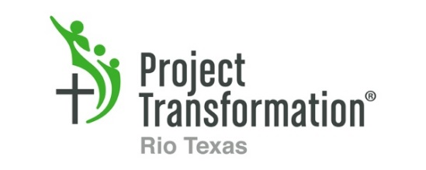
Summer Volunteer Opportunities

One-to-One Reading Volunteers
Project Transformation is looking for caring volunteers to read with our summer day camp participants. The literacy component of Project Transformation is an exciting opportunity for volunteers to interact with the children in a one-to-one setting. The reading component takes place on Monday-Thursday from 10:00am-12:00pm. (Please arrive at 9:30 your first time.) We welcome both individuals and groups.
Dates: June 18- July 31

Intern Dinners: San Antonio
Calling all Chefs! This summer, 26 college students will serve in Project Transformation’s summer program in the greater San Antonio area. Groups and individuals provide dinner Sunday through Thursday in San Antonio at Morningside Ministries. This is a great opportunity to serve, encourage and get to know young people making a difference!
Dates: June 3 through August 2

Other Engagement Opportunities
Family Fun Nights: Churches host family engagement events twice during the program with dinner, games, and family fun! Help with dinner, activities, supplies and more! Checkout the website or contact us for more information.
Do you have a special passion or talent? Let us know what it is and how you want to get involved with the participants and/or the intern communities—the only limits are you own imagination! Checkout the website or contact us for more information.

Book Drive
A full and diverse library is needed at every site. Use our Amazon Wish list to hold a book drive, and donate books directly to Project Transformation Rio Texas. Select the books (new or used) to put in your shopping cart, and then pick Project Transformation Rio Texas for the shipping address. From there, check out as normal! Just save the receipt for your taxes since it's a donation.

All the signups (Get Involved) and the Amazon link can be found on the website.
www.ProjectTransformation.org/rio-texas
For more information contact:
Program Director—Kaci Boylan
(210) 408-4500
kboylan@riotexas.org
Summer Volunteer Opportunities

One-to-One Reading Volunteers
Project Transformation is looking for caring volunteers to read with our summer day camp participants. The literacy component of Project Transformation is an exciting opportunity for volunteers to interact with the children in a one-to-one setting. The reading component takes place on Monday-Thursday from 10:00am-12:00pm. (Please arrive at 9:30 your first time.) We welcome both individuals and groups.
Dates: June 18- July 31

Intern Dinners: San Antonio
Calling all Chefs! This summer, 26 college students will serve in Project Transformation’s summer program in the greater San Antonio area. Groups and individuals provide dinner Sunday through Thursday in San Antonio at Morningside Ministries. This is a great opportunity to serve, encourage and get to know young people making a difference!
Dates: June 3 through August 2

Other Engagement Opportunities
Family Fun Nights: Churches host family engagement events twice during the program with dinner, games, and family fun! Help with dinner, activities, supplies and more! Checkout the website or contact us for more information.
Do you have a special passion or talent? Let us know what it is and how you want to get involved with the participants and/or the intern communities—the only limits are you own imagination! Checkout the website or contact us for more information.

Book Drive
A full and diverse library is needed at every site. Use our Amazon Wish list to hold a book drive, and donate books directly to Project Transformation Rio Texas. Select the books (new or used) to put in your shopping cart, and then pick Project Transformation Rio Texas for the shipping address. From there, check out as normal! Just save the receipt for your taxes since it's a donation.

All the signups (Get Involved) and the Amazon link can be found on the website.
www.ProjectTransformation.org/rio-texas
For more information contact:
Program Director—Kaci Boylan
(210) 408-4500
kboylan@riotexas.org

